**Q1: Calculate the time for each process, define the priority?**

**Answer :**

As an example of this approach, consider a system with threeI/O devices: a printer, a disk, and a communications line, with increasing priorities of 2, 4, and 5, respectively. A user program begins at t=0. At t=10, a printer interrupt occurs; user information is placed on the system stack and execution continues at the printer interrupt service routine (ISR).While this routine is still executing, at t=15, a communications interrupt occurs. Because the communications line has higher priority than the printer, the interrupt is honored. The printer ISR is interrupted, its state is pushed onto thestack, and execution continues at the communications ISR. While this routine is executing, a disk interrupt occurs (t=20). Because this interrupt is of lower priority, it is simply held, and the communications ISR runs to completion.-When the communications ISR is complete (t=25), the previous processor state is restored, which is the execution of the printer ISR. However, before even a single instruction in that routine can be executed, the processor honors the higher priority disk interrupt and control transfers to the disk ISR. Only when that routine is complete (t=35) is the printer ISR resumed. When that routine completes (t=40), control finally returns to the user program .

[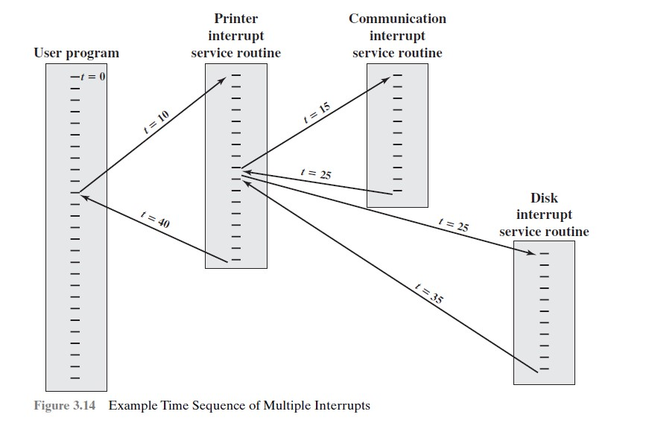](https://1.bp.blogspot.com/-IUM1llF10tg/WPm8V_G-gCI/AAAAAAAAEBs/i8JKSVQsQostgum0eiF92b4bFATMSxI6QCK4B/s1600/sequence-of-multiple-interrupts.jpg)

***Rana Alsaid Ibrahim***

***Sec:3***